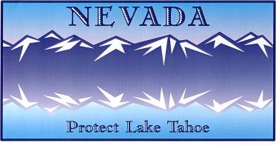
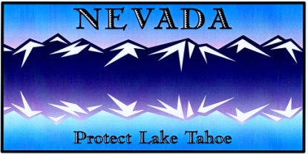
2023 LAKE TAHOE LICENSE PLATE PROGRAM GRANT SUBMITTAL REQUIREMENTS

Please refer to the 2023 Lake Tahoe License Plate Program Grant Procedures for further regulations, definitions, requirements, grant approval processes, matching fund requirements, and acceptable uses of grant money. Funding can be utilized for programs such as, but not limited to, implementing projects to improve the environment (e.g. water quality, aquatic invasive species removal, recreation infrastructure improvements), educational outreach, scientific research, and monitoring.
- Education & Implementation Proposal Submittal Requirements
Implementation or education programs/projects shall include the following information, without limitation:
Section and Content | Length and Format
I. Completed Application (form provided by the Division) | 1 page
II. Proposal Narrative  - A detailed description of the program or project;  - Deliverables/products;  - An estimated time schedule for completion of each project deliverable and the overall program or project;  - If applicable, proof of any title to land, lease or easement that is required for carrying out the program;  - If applicable, a plan for the operation and maintenance of the project for a period of at least 20 years.  - A detailed description of how the project or program will contribute to the preservation and restoration of the natural environment of the Lake Tahoe Basin;  - If applicable, documentation should be submitted that demonstrates the applicant’s ability to obtain local, state and federal permits for the project. | Maximum of 7 pages
III. Figures (if applicable)  - A map of the project location;  - Preliminary or conceptual design drawings;  - Schematics;  (Please note, any figures included in the Proposal Narrative will be counted as part of the page limit for Section II.) | Maximum of 6 pages. All figures must be in JPG or PDF format.
IV. Budget (form provided by the Division)  - The amount of money requested for the program or project;  - The total projected cost of the program or project;  - If applicable, sources of matching funds and a statement regarding if matching funds have been secured;  - An itemized list (detailed) of program or project costs, including any subcontracts or equipment needs for individual project deliverables;  - Where applicable, the budget must include line items to complete draft and final project reports. Payments for draft and final project reports shall not be made until satisfactory completion of each report.  - Travel reimbursements shall be made based on the State of Nevada approved reimbursement rates and regulations and will be based on actual miles traveled for the project.  - The budget should list the position title and base salary rate for individuals who will work on the project. In addition, salaries should contain a breakdown of the estimated number of hours that each position will perform for each task. | For multi-year  projects, please include a one-page budget with cost breakdown for each year of the project. Budgets must be provided in Microsoft Excel format.

- Research & Monitoring Proposal Submittal Requirements
For research or monitoring projects, please use the format instructions found below. Research and monitoring proposals which do not follow this format will not be considered for funding due to the independent technical peer review process.
Item and Content | Length/ Format
I. Completed Application (form provided by the Division) | 1 page
II. Proposal Narrative  - A detailed description of the program or project;  - Justification statement;  - Background/problem statement;  - Goals, objective(s), and statement of hypotheses to be  tested (if applicable);  - Approach, methodology, and geographic location of  research;  - Deliverables/products;  - A detailed schedule of events/reporting and deliverables.  - If applicable, proof of any title to land, lease or  easement that is required for carrying out the program;  - If applicable, a plan for the operation and maintenance of the project for a period of at least 20 years.  - A detailed description of how the project or program will contribute to the preservation and restoration of the natural environment of the Lake Tahoe Basin;  - If applicable, documentation should be submitted that demonstrates the applicant’s ability to obtain local, state and federal permits for the project.  - Projects that include data collection are expected to employ experimental designs that maximize the likelihood that resulting information can be used directly to guide future land and resource management. Data collection design and techniques should be described in the proposal.  - If applicable, a discussion should be provided that identifies how the project provides resource management data applicable to the Nevada side of the Tahoe Basin in cases where project components are geographically located outside the Nevada Tahoe borders.  - If applicable, explain relationships between the proposed research or monitoring project and previous research and monitoring projects. Be sure to include specifics on other research or monitoring referred to in your proposal as technical peer reviewers may not have local knowledge of these studies.  - If applicable, please demonstrate that the research or monitoring proposal is consistent with desired conditions and regional status and monitoring programs identified by the TRPA Regional Plan update.  - If applicable, please identify that management agency representatives will be included on project monitoring or research teams.  - Acknowledgement that NDSL may submit final reports for a technical review upon completion. Please note, the Division will make final reports available to the public upon termination of the agreement regardless of publishing status. | Maximum of 7 pages
III. Figures (if applicable)  - A map of the project location;  - Preliminary or conceptual design drawings;  - Schematics;  - Sample model outputs.  (Please note, any figures included in the Proposal Narrative will be counted as part of the page limit for Section II.) | Maximum of 6 pages. All figures must be in JPG or PDF format.
IV. Budget (form provided by the Division)  - The amount of money requested for the program or project;  - The total projected cost of the program or project;  - If applicable, sources of matching funds and a statement regarding if matching funds have been secured;  - An itemized list of the costs of the program or project, including any subcontracts, in accordance with the descriptions of work;  - Where applicable, the budget must include line items to complete draft and final project reports. Payments for draft and final project reports shall not be made until satisfactory completion of each report.  - Travel reimbursements shall be made based on the State of Nevada approved reimbursement rates.  - The budget should list the position title and base salary rate for individuals who will work on the project. In addition, salaries should contain a breakdown of the estimated number of hours that each position will perform for each task. | For multi-year  projects, please include a budget with cost breakdown for each year of the project. Budgets must be provided in Microsoft Excel format.
V. Abbreviated CV(s) for Principal Investigator(s)  If applicable, please include names, institutions, and abbreviated CV(s) (curriculum vitae) or resumes for the investigator(s) including a list of relevant publications and reports which will be used for evaluating the capabilities of the investigator(s) to successfully complete the proposed project). | No more than 2 pages each

- BUDGET FORMS
Indirect Cost Rate Option
Please note, the maximum Indirect Cost Rate (IDC) accepted for reimbursement is not to exceed 40%. The negotiated maximum reimbursable IDC for grants with the Nevada System of Higher Education is 10% for research projects and 8% for all other non-research projects.
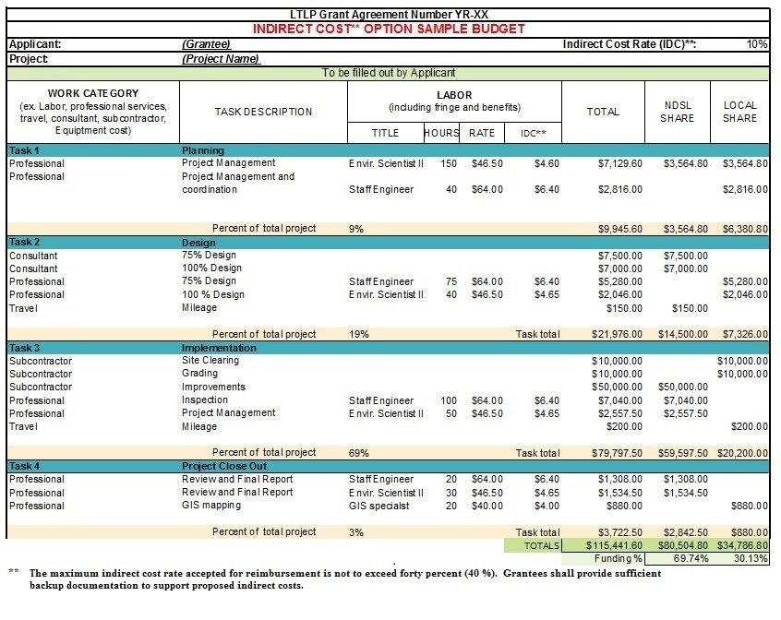

5% Administration Fee Option

