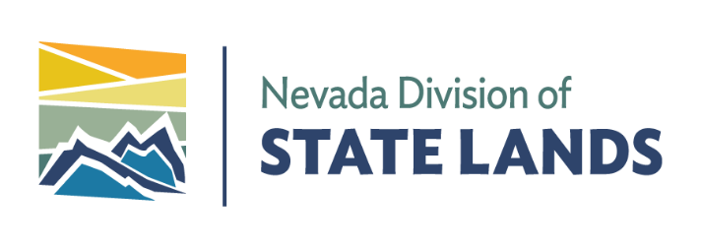 | STATE OF NEVADA  Department of Conservation & Natural Resources  Steve Sisolak, Governor  James Lawrence, Acting Director  Charles Donohue, Administrator

August 17, 2022

Dear Interested Parties,

The Nevada Division of State Lands is seeking grant applications for the use of funds from the Nevada Lake Tahoe License Plate Program.

Funds available for this round: approximately $500,000

Grant information:

- Grants are available to public agencies and nonprofit organizations for projects or programs that promote the preservation and restoration of the Lake Tahoe Basin.
- Proposals for projects listed on the TRPA 5-year Environmental Improvement Program list will be prioritized for funding.
- A matching contribution of at least 25 percent is required of all projects or programs, unless the applicant is a Nevada State agency. A match is not required for Nevada State agencies.
- Allocation of these funds will be competitively determined.
- Lake Tahoe License Plate grants are on a reimbursement basis only.
- The maximum indirect cost rate accepted for reimbursement is not to exceed 40 percent.
- Application forms, procedures, and examples of past projects are located on our website at http://lands.nv.gov/resource-programs/tahoe/water-quality/tahoe-license-plate-program.

A Technical Advisory Committee (TAC) will be established to review grant proposals and make recommendations regarding grant awards. The proposed committee will likely include representatives from the Nevada Division of State Lands, Nevada Division of Environmental Protection, Nevada Department of Wildlife, Tahoe Regional Planning Agency, United States Forest Service, and League to Save Lake Tahoe. All monitoring and research proposals will undergo technical peer review in addition to TAC review.

If you are interested in applying for a grant through this program, please submit the application form and a proposal in accordance with the Lake Tahoe License Plate Grant Submittal Requirements. Your application package must contain an electronic copy of the application document package (in PDF or Word format), copies of all images contained in the proposal (in JPG format), and copies of all budgets (in Excel format) on a flash drive.

Email submissions and links to Google Drive will NOT be accepted. Physical applications must be received at the Nevada Division of State Lands, 901 South Stewart Street, Suite 5003, Carson City, NV 89701 by November 4, 2022 at 4 p.m. Applications received after November 4, 2022 at 4 p.m. will not be eligible. We are expecting to award grants during the month of February 2023.

Please feel free to call me with any questions at (775) 684-2725.

Sincerely,
Chris LaCasse
Water Quality Coordinator
Nevada Tahoe Resource Team

